The mystery hidden behind the domestic violence cases in Hong Kong

**The mystery hidden behind the domestic violence cases in Hong Kong**

WANG HANXUE·BI ZUOMING·WANG PEIJIE·

CHUI SING YUK·CHAN CHEUK YEUNG

Department of communication, Hong Kong Baptist University

AIDM7410 Computational Journalism

Dr. ZHANG Xinzhi

May 9, 2021

In the Yuen Long district of the New Territories, Hong Kong, a place called "Tin Shui Wai", surrounded by a lot of villages, it was also a forgotten corner of the prosperous society of Hong Kong, filled with new arrivals. On April 11, 2004, a horrific crime took place here, instantly shocking the whole of Hong Kong.

A housewife and her two 5-year-old children were murdered in their home, decapitated to a bloody pulp. More chillingly, there was also a man lying in a pool of blood with heavy abdominal injuries at the scene. The man was still breathing when the local police arrived, but he died on the 12th day after the emergency medical treatment. A family of four suffered from murder, all of them fell in a pool of blood, the wife and children died in a horrible way, it was evident that the murderer's methods were very cruel, and the follow-up development is beyond everyone's guesses, the case was shocked by the exposure of the whole of Hong Kong.

The woman who was killed is named Jin Shu Ying, from Sichuan, her husband was also the male owner of the family, Lee Pak Sum, was an ordinary renovation worker in Hong Kong, and they got married in 1998 in Chengdu, Sichuan. Not long after their marriage, they were blessed with two lovely daughters. But in 2003, Lee brought his two daughters back to live in Hong Kong, and in January of the next year, Jin also arrived at the public housing estate in Tin Shui Wai where her husband and children were temporarily living. What was unexpected was that Lee was already unemployed and was surviving on government assistance. He thought he could apply for more unemployment benefits with the arrival of his wife, but the government not only rejected his application, but also reduced his original benefits on the grounds that "the mother could take care of the children".

Over time, the financial situation of the family took a sharp downward turn, and the youngest daughter told Jin in secret that her father had acted weirdly and inappropriately towards herself and her sister during her away time, adding to the already fractured relationship between the couple due to financial problems. Lee would sometimes wantonly destroy things in the house for unpleasant matters, and a neighbor living next door to them once lamented, "The man of the house is a psychopath!" . After this, Jin had applied for a new public housing from the community. She intended to take her two daughters and move out of the area secretly and take the opportunity to stay away from Lee. However, according to Hong Kong's law, only Hong Kong residents who have obtained a Hong Kong identity card are eligible to apply for public housing. When Lee heard about this, he beat her severely and threw her out of the house in the middle of the night.

Meanwhile, Jin repeatedly sought assistance from the community, but her requests were not successful. Jin also confessed to the police that she had also beaten her husband, and the nature of the case changed from domestic violence to a family dispute.On April 11, Lee threatened to take her two daughters away from her by phone. She had no choice but to return home alone. As soon as she entered the house, the three of them were knifed by Lee, and Jin died after being stabbed seven times to protect her daughter. The two children were also not spared, and Lee reported to the police that his wife had cut his daughter and wounded him, and eventually died after being taken to the hospital. All members of the family died.

This event was even made into a movie later, and the murder was brought to the big screen, warning everyone that there are only 0 and countless times of domestic violence. In Hong Kong, there are still plenty of domestic violence cases like this, and we will use the most intuitive data to tell the various reasons hidden behind the domestic violence cases in Hong Kong.

*External Factors*

*The causes of domestic violence from the peak*

We have summarized the total number of domestic violence cases in Hong Kong by collating the domestic violence statistics provided by the Social Welfare Department from 2005 to 2020, thus drawing a line chart. Why we can see the number of domestic violence cases in these two years at a glance can be explained by the significant rise and fall of the data around these two years. It is certainly worthwhile to explore the conspicuous numbers, so what exactly were the dramatic changes that took place in Hong Kong from 2007 to 2008?

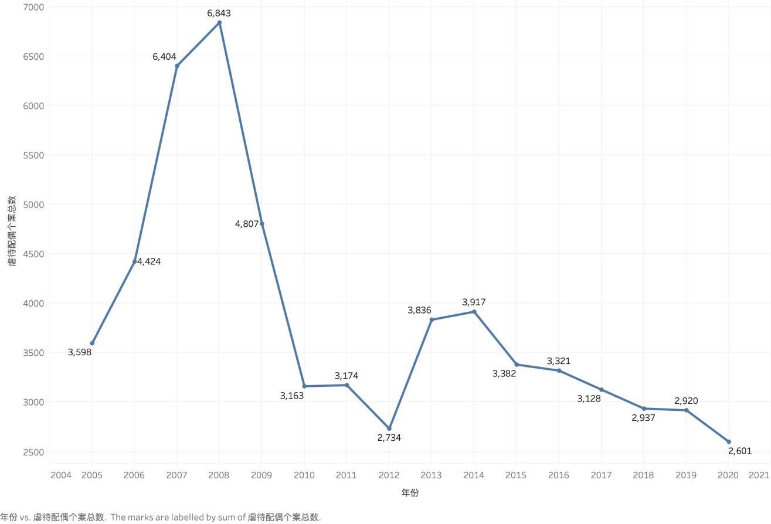

(Figure 1:Total number of domestic violence cases from 2005 to 2020)

When thinking of Hong Kong, most people think of it as one of the major international financial centers in the Asia-Pacific region. Under the general trend of global economic integration, Hong Kong has gradually developed an economy that is dominated by the commercial and financial industries, and has jumped to become an international financial center. While such global economic integration has indeed brought great business opportunities to Hong Kong, the negative impact it has had cannot be ignored. Between 2007 and 2008, Hong Kong was hit by the Asian financial crisis, resulting in a very direct and severe impact on the economy of Hong Kong. It was a global stock market crash caused by the uncontrollable subprime storm in the United States, and led to a rapid decline in the Hong Kong market over time. Countless companies have gone bankrupt, countless people have lost their jobs, and many families have suffered very heavy financial pressure as a result. In such a difficult situation, both middle class and grassroots families were affected by the economic downturn, and the emotions of family members were also negatively affected, and the pressure of life was not properly dealt with, so it was easy to have conflicts with other family members and cause various family problems. Economic problems have become the main cause of domestic violence over time.During these two years, the Hong Kong Social Welfare Department received more than 6,000 cases of domestic violence, and we can see a very direct relationship between the economic situation and family harmony.

*Two amendments to the domestic violence regulations*

Why did domestic violence cases decline in 2009? We found that this was due to the government's review of the Domestic Violence Ordinance. Finally, the amendment to the Domestic Violence Regulations was passed in June 2008, and the revised "Domestic Violence Regulations" were formally implemented on August 1, 2008. The revised "Domestic Violence Regulations" broaden the scope of the regulations. The revised "Domestic Violence Regulations" played a more obvious role. More injunctions were issued, and more domestic violence was stopped in time.

The Hong Kong Domestic Violence Ordinance is a civil law enacted by the Hong Kong government in 1986. Its main function is to draft provisions on civil remedies for victims of domestic violence (including sexual and mental violence), so that victims of domestic violence—one of the marriage or one of the cohabiting men and women may apply to the court for an injunction to avoid harassed by the other party.

The appearance of the Domestic Violence Ordinance was due to the increase in the number of spouse abuse cases at that time, most of which were wife battering cases. The severe domestic violence situation has aroused social concern.

The civil framework of the Domestic Violence Ordinance is to provide additional civil remedies for the special circumstances and needs of certain types of related persons. Let both parties calm down and deal with the problem during the separation time. It also allows people in close relationships to provide a remedy with a reprieve for ignoring the reporting of violence by cohabitants.

However, even the early domestic violence regulations did not provide a good protection for victims of domestic violence. The main reason is that the Domestic Violence Ordinance were formulated to protect the safety of battered women. The scope of protection in the early Domestic Violence Ordinance was too narrow. And the government has not reviewed this in 19 years.

"Domestic Violence Ordinance" Since 1986, women's groups have been criticizing the government's domestic violence policy. They believe that this domestic violence policy tends to attach importance to maintaining family integrity. They think that the government has neglected the personal safety of women. The government failed to act in time and failed to prevent the tragedy from happening.

The Domestic Violence Ordinance has been in use in Hong Kong for more than 20 years without any amendments. However, Hong Kong society is changing rapidly, and the original domestic violence regulations are no longer sufficient to protect victims of domestic violence. Family problems are getting worse.

The laws and policies do not provide adequate protection to victims. Front-line social workers and police lack professional training in dealing with domestic violence. They can not effectively use relevant regulations to protect victims. As a result, the victim encountered many difficulties in the process of seeking help.

The reason that prompted the government to revise the Domestic Violence Regulations, which has been implemented for more than 20 years, was in 2004. Many domestic violence tragedies occurred this year. Especially in the death of Jin Shuying, from this extremely cruel domestic violence case, the government realized that the original "Domestic Violence Regulations" can no longer provide protection for victims of domestic violence. Hong Kong's judicial and law enforcement systems have failed to effectively prevent the occurrence of domestic violence. The front-line professionals still lack knowledge and sensitivity in dealing with domestic violence. From this tragic domestic violence case, the Hong Kong government is willing to learn from it so as to avoid repeating the same mistakes and avoiding the tragedy from happening again.

The government reviewed the Domestic Violence Ordinance. Finally, the amendment to the Domestic Violence Ordinance was passed in June 2008, and the revised "Domestic Violence Ordinance" was formally implemented on August 1, 2008.

The revised "Domestic Violence Ordinance" broaden the scope of the regulations. Originally, the harassment of domestic violence between spouses and heterosexual cohabitants was extended to include former spouses, former heterosexual cohabitants, and members of direct and extended family relationships. The revised Domestic Violence Ordinance also empowers the court to issue a "Suppression of Harassment Order" to require abusers to participate in anti-violence programs to help them change their violent attitudes and behaviors.

After the amendment of the Domestic Violence Ordinance, the number of injunctions issued has increased significantly. In the first seven months of 2008, the court issued a total of 13 injunctions under the original Domestic Violence Ordinance, but within two months after the amendment of the law came into effect in August, 7 injunctions have been issued.

In the first amendment to the regulations, same-sex couples were not protected by the relevant regulations. This has caused many women and gay rights organizations to be dissatisfied with the Domestic Violence Ordinance. This also raises the suspicion of discrimination based on sexual orientation.

The dissatisfaction of the masses was answered. Amend the scope of domestic violence protection to extend to same-sex cohabitants. Since then, the Domestic Violence (Amendment) Ordinance 2008 came into effect on August 1, 2008.

The Legislative Council passed the Domestic Violence (Amendment) Bill 2009 on December 16, 2009, and came into effect on January 1, 2010. Same-sex cohabitants and former same-sex cohabitants are included in the protection scope of the Domestic Violence Ordinance, allowing cohabitation relationships one party, regardless of the same sex or opposite sex, can apply to the court for an injunction to avoid harassment by the other party. The ordinance was also renamed the "Family and Cohabitation Violence Ordinance."

*Internal factors*

After exploring the two main external factors of domestic violence, let's look at the internal factors within the family.

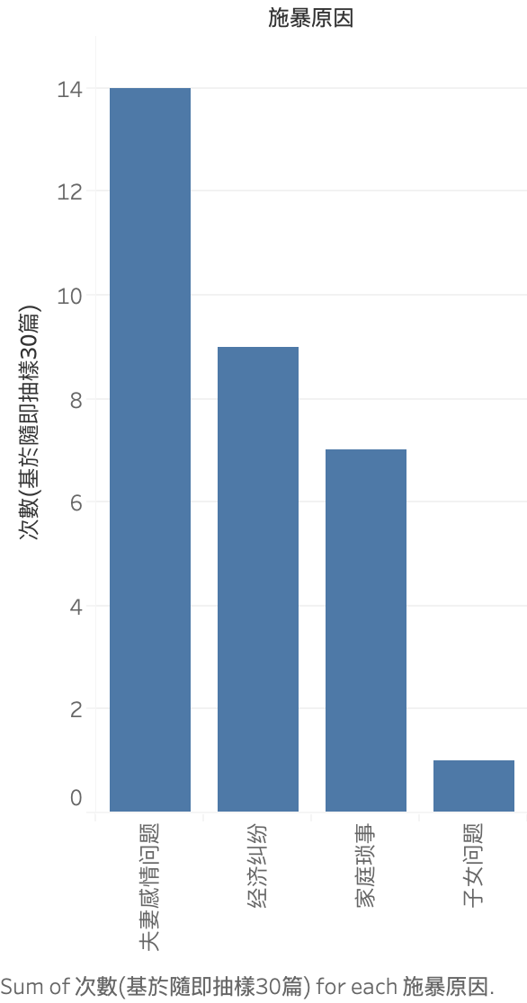

(Figure 2:Internal causes of 30 domestic violence cases)

First, there are the emotional issues. Men mainly use verbal messages to process things rationally. In contrast, the right side of the brain is more developed for emotional processing and tends to be more emotionally oriented than organically figuring things out. Sparks often occur between men and women because of differences in brain structure. In this situation, when a man has no idea why a woman is angry and rational solutions often fail, what he wants to say turns into a fist. In fact, the original intention of men is to reconcile, but can not express their feelings very well. From the psychological point of view, male violence comes from the "uneasy" psychology. Men are not good at expressing, nor will they pour out their inner distress and annoyance. Even if you ask them directly, the answer will be nothing. Over the years, the stress and anxiety in a man's heart can build up and eventually turn into domestic violence. Men who are prone to domestic violence have a rather tender period known as the "honeymoon period" after the abuse. It's a fairly brief period, and after that, the men start abusing again. Under the control of hallucinations and delusions, schizophrenics are likely to have serious violent behavior and self-mutilation behavior. When come on, their regular meeting appears sense perception function obstacle, sometimes regard his spouse as a ghost to have a beat-up, often hit the family member nose black eye swollen, head broken and blood flow even disability and do not know. Most of the perpetrators of domestic violence are men. Among some men, they believe that men are superior to women and regard domestic violence as a normal family rule or an effective means to force women to obey their orders.

The economics factor will cause domestic violence. Lack of economic status is the main cause of domestic violence. Without economic status, one party becomes the subordinate of the other party. Once it has absolute authority in the family, this kind of unrestricted right expands more and more as time goes by. It is confused for money and vents more displeasure to the other party. Because women do not directly create value for them, and women also do their duty of raising and supporting their children, husbands and families in social life, women also feel unfair, so they cannot handle the contradiction between the two, and domestic violence will occur. Economic factors are the material conditions of domestic violence. On the one hand, low economic income is prone to violence. At present, some urban workers are laid off, family income is relatively reduced, life pressure is increased, easy to cause family conflicts, leading to domestic violence. Of the 400 U.S. psychiatrists surveyed, 43 percent agreed that "incompetence is the most common reason husbands beat their wives." Husbands who feel incompetent tend to belong to the lower-income class. They tend to look down on themselves, feel insecure about their responsibilities as husbands, fathers and breadwinners, fear losing their jobs, and believe that their incomes are too low to make ends meet. However, in some rural areas with poor living conditions, poverty makes some family members deal with family relations passively and apathetic, or even abandon their responsibilities, leading to frequent domestic violence. Some even lead to the tragedy of family destruction. For example, in backward rural areas, adult children beat and scold elderly parents, in addition to moral factors, the rural elderly have no fixed economic income, lack of self-protection ability is not unrelated; On the other hand, with the differentiation of economic income and the inequality of economic status, the imbalance of economic income between the two parties in marriage often changes the status and image of one party in the family, leading to the deviation of the relationship between the two parties, resulting in love and marital change, and thus causing family conflicts and domestic violence.

More and more families in the family began to pay attention to the children's education, can be in the method of education some parents lack of consideration, due to the children's grades down, parents feel no light on the face, so the child to beat and scold, some even beat the children black and blue all over. In the education of children, there will be many differences between husband and wife, between the elder and the younger generation, in front of these differences will inevitably quarrel, so in the long run, will form resentment, resulting in domestic violence phenomenon.

In some families, the husband or wife has some bad habits that are difficult to change, such as spreading gossip, which leads to neighborhood disharmony, such as gambling and playing cards, which leads to many conflicts between the husband and wife. They keep friction over these small things, which eventually leads to domestic violence.

The domestic violence will also be caused of sex inequality. The unequal status of men and women in the society and family, coupled with the characteristics of female gender, determines the weak status of women. Most men play the role of the perpetrator in domestic violence cases. Domestic violence is mainly the beating of the wife by the husband, with a few exceptions when the husband is the target of violence. Aggression, dominance and power are seen as the characteristics of men. In sexual behavior, men always play the role of aggressor, while warmth, kindness and charm become the characteristics of women. The traditional role of women is to be a good wife and mother, and the behavioral characteristics are submissive. Urban civilization plays a relatively modern role model, which emphasizes the equality of the status of men and women and the independence of women themselves. Equality between men and women means that women participate in the same activities as men, and at the same time means that women deal with all kinds of pressures and setbacks in life as men. But women's pursuit of traditional roles is still encouraged on a deep cultural level. Girls are always encouraged to be obedient and identify with their future roles as housewives and mothers. This creates a conflict between traditional and modern gender roles. From the long history, women are in a subordinate position in both the society and the family. Compared with men, they belong to the disadvantaged group in the society and the family, so they are easy to become the victims of domestic violence. This is one of the concrete manifestations of the traditional husband power thought and the unequal status of men and women in reality.

The victim's sense of tolerance or fear further encourages the abuser's behavior. Under the violence, the victims generally do not have the ability to resist, in order to seek temporary peace, take the attitude of submission, endure to recognize, in an attempt to win the sympathy of the violence. The main problem that society has in restraining domestic violence is that victims do not report it and do not want to prosecute abusive husbands. Many women are afraid of being laughed at if they admit that their marriage has failed. There are also women who are too kind and generous and have fantasies, always expecting that their husbands will come back one day. They tend to have a high opinion of their marriage, and there are lulls in their husbands' abusive behavior, which encourages them to endure for fear that they may find it difficult to find another partner after divorce, or that they may be inferior to him." At least it's a home!" Some women report their problems to organizations or to their husband's units, only to be reprised even more severely. Some other women belong to economic and independent life ability more bad of the class, their intelligence and level of education is poor, so to avoid this kind of ideal marriage will not result in they cannot survive, so had to "appointed" accept this poor situation, in exchange for economic security and guarantee, their inner existence inferiority mentality, the lack of self-esteem, self-confidence, Always think oneself is a head lower than the man, can only submit; Some women get married early to escape parental abuse, only to be abused by their husbands after marriage, and then they can't go back to their parents to escape new abuse. Some women think that mothers have not lived like this all their lives? What can I do?" Men are always angry." Compared to domestic violence and general violence, the obvious difference is that the former is not just a one-time to family member's injury, but a continuous and long-term, this is due to the weakness of the victims, it is important to note that even though women generally belong to the vulnerable groups in society and family, but they also has a limit to a domestic violence patience, When pent-up humiliation and anger erupt, it can easily degenerate into serious criminality.

The comprehensive quality of the violent low is an important cause of family violence, with the reform and opening up the western way of life and values, outlook on life a huge impact on people's ideas, some people's moral dislocation or decay, with an affair, extramarital love to show off the capital, proud, this inevitable hurt your spouse's infidelity self-esteem. It causes the collision of moral values and leads to the occurrence of domestic violence. Most of the abusers have poor self-control, rough temperament and are aggressive. This kind of people often do not control themselves, fight with people, or even recognize their own relatives, regardless of age, handling the relationship between husband and wife is the use of direct, violent means, easy to happen domestic violence cases, and is a major case.

The social recognition of violence to some extent is the social basis of domestic violence. Domestic violence is not only a family phenomenon, but also a social phenomenon with profound roots. Social recognition of violence, especially female recognition of violence, is the social basis for the emergence and existence of domestic violence. In our country, the traditional thought of husband's power is more prominent in People's Daily behavior.

*Public Attitudes and Government Measures*

We mentioned earlier a lot about the relevance of domestic violence. Going back to the public perspective, in today's society, most of the prerequisites for an issue to be taken seriously is to have a certain amount of topic buzz. We crawled through the comments under YouTube videos about domestic violence and got a total of 1305 comments to make a high frequency word cloud. From the graph, we see a lot of descriptions of domestic violence objects, such as "man", "woman", "child", etc. There is also no lack of justice words, such as "police" and "law". It can be seen that the attitude of many people in the comments is supportive of anti-domestic violence, and there are some behavioral measures provided against domestic violence, and likewise it can be seen that there are voices of solidarity with these people, so we also find the word "support". Against the backdrop of frequent domestic violence cases every year, the flag of anti-domestic violence has been raised high, and we live in a new society that further emphasizes gender equality, and in fact, domestic violence is an extreme manifestation of gender inequality. The number of domestic violence cases in Hong Kong are still around 2500 cases every year, which is considered a staggering number. From the word cloud there are also more words for men, why are the perpetrators of violence mostly men? This is closely related to the patriarchal system of male superiority over female and gender discrimination. So when you suffer from domestic violence, you should be brave enough to stand up against it, not just cowardly and condescending, because from the analysis of social concern, we can see that the public attitude is to put an end to domestic violence, there are many supportive voices such as "encourage", and more and more people are willing to bring warmth to those who suffer from domestic violence. In the word cloud, we also see the word "heartache". When it comes to the topic of domestic violence, while we condemn the abusers, we also pay more attention to the protection of the victims of domestic violence, and have made several amendments to the domestic violence ordinance in Hong Kong to increase the cost of domestic violence, so that domestic violence can no longer be unscrupulous and the abusers can bear the corresponding responsibility. The two clues behind the causes of domestic violence are also echoed in the emergence of the word "money" linked to the economy and the "problem" linked to the internal conflicts within the family, which are also commonly reflected in social commentaries on the causes of domestic violence.

From the public attitude of the society, it is doubly gratifying that most people do not feel that domestic violence is a joking matter. The original news reports and TV dramas have conveyed the lines of "women are not good if they don't fight" with similar comments, which is very similar to the nature of another topic "sexual assault", and some people will comment on vulgar dumping content like "flies don't bite seamless eggs", but today's social comments, from the word cloud, are seen to be the voice of anti-domestic violence.

With public awareness, the attitude of the relevant authorities has been changed greatly. If domestic violence had been happening 20 years ago, people would probably look at it and be done with it, but now it is definitely different. With the diffusion of new media and the increasing awareness of women's rights, they are not acceptable to domestic violence. The public's level of awareness has also been greatly upgraded.From the initial women's rights and no daring to speak out, the topic in society now still belongs to stars and celebrities. With stars suffering from domestic violence and being brave enough to speak out, it has guided more and more people to dare to resist, until now, many warm words from the word cloud are seen to bring warmth and encouragement. The public attitude of the society also tells all those who suffer from domestic violence to take up the weapons of the law to defend their health and interests, when they suffer from this kind of harm again, they can think that there are so many people to encourage you to resist, and there will be less and less domestic violence cases in Hong Kong.



(Figure 3:Keywords in comments)

At the moment, the government provides help to domestic violence victims through departments such as the Social Welfare Department. Currently, the Social Welfare Department has a hotline that is ready to listen to requests under its domain. The [website](https://www.swd.gov.hk/en/index/) also contains links to numerous non-governmental organizations which also provide ways to seek help to those who suffer from domestic violence. In particular, The Hong Kong Federation of Women’s Centres ([HKFWC](https://womencentre.org.hk/En/About/)) and Against Child Abuse ([ACA](https://www.aca.org.hk/index.php#.YI_Z9bUzZPZ)) are the more well known NGOs that give effort to assist victims of domestic violence every year.

The Hong Kong Social Welfare Department had also been publishing data on the received reports of domestic violences yearly. Apart from that, the department also organized some activities. For instance, according to their official website, in the year of 2019 - 2020, they have organized 7 series of activities and the features are as follows:

1. Publicity Campaign on Strengthening Families and Combating Violence
   * Uses a short video to show the serious impact of witnessing parental conflict on child development, aims to help the public gain understanding on the impact of family conflicts on children, and to promote co-parenting amongst separated or divorced parents for their children’s best interests.
   * Nearly 2.6K district-based public education programmes and activities with a total attendance of over 98K were organized by the District Social Welfare Offices
2. Multi-purpose Crisis Intervention and Support Centre
   * Over 24K calls received, 584 sexual violence cases handled
3. Refuge Centres for Women
   * 60.8% average utilisation rate
   * 627 cases served
4. Family and Child Protective Services Units
   * 6.7K
5. Victim Support Programme for Victims of Family Violence
   * 710 service users served
6. Support Programme for Enhancing Peaceable Relationship
   * Total attendance of 411
7. Specialised Co-parenting Support Centres
   * Commenced since October 2019
   * 257 cases served

However, there is still quite a noticeable room for improvement for the Social Welfare Department. Their website’s infrastructure and interface seems aged and does not fit the expectations of a website that should be easy to navigate for any type of victim that can suffer from domestic violence. For a victim to find domestic violence related help on the website, they have to go through the steps of “Public Services > Family and Child Welfare > List of Services > Victim Support Programme for Victims of Family Violence”. We then investigated whether the “Victim Support Programme for Victims of Family Violence” web page is easy to get to with the search function of the website. Unfortunately, the website’s search function also does not seem to be functioning well in the current generation of web browsers, as common browsers (e.g. Google Chrome, Microsoft Edge, etc.) would alert their users with prompts in the likes of “This form is not secure”, or “The information you’re about to submit is not secure”. With the increasing awareness about privacy and information safety while browsing the web people have in the current age, a lot of users may immediately click away, thinking they may have entered a fake website if they are prompted with those messages. Overall, there are plenty of notable inconveniences from the website that accumulates into an uneasy user experience and can very likely demotivate a user from continuing to look for what they need on the web site. While the hotline is a way that users can fall back on, it would be best that the path between victims and getting the help they need can also be as smooth as possible if they so choose to get help through the website. The easier it is for a victim to request and receive help, the better the Department of Social Welfare can exercise its purpose in helping to build a community with harmony bit-by-bit. Some non governmental organizations that offer general counselling have created systems for users to book counselling appointments online. We believe that a similar system should be implemented on the Social Welfare Department’s web site so that it is available for victims of domestic violence as well, and the Social Welfare Department can examine these existing examples to improve their own systems.

Apart from constructing a better system for receiving requests for help from the web, we believe efforts in educating the public are always important and we believe the government should continue growing the scale of those activities. On the other hand, for the services made to offer help to victims of domestic violence, we believe they are rather under-advertised and should be promoted in more ways in order to gain more public attention. The previous advertisement that was produced by the Social Welfare Department on the issue of domestic violence was 6 years ago and it is not being advertised on traditional or online media frequently.

Apart from the primary and frontline method offered from the Social Welfare Department, there had been previous efforts in investigating domestic violence from the government. The Legislative Council had a subcommittee on strategy and measures to tackle domestic violence and sexual violence in the Legislative Council from 2012 - 2016. Their investigation results and reports can be found on the respective [web page](https://www.legco.gov.hk/general/english/panels/yr12-16/ws_dv.htm).

In terms of more recent efforts, the legco had also discussed relevant laws on domestic violence and sexual violence, details can be found on [this document](https://www.legco.gov.hk/yr20-21/english/panels/ws/papers/ws20210308cb2-832-5-e.pdf) from the Legislative Council’s website. The document describes the current efforts on tackling domestic violence from multiple levels and aspects. To name a few, the current preventive measures, support services, specialised support for victims of sexual violence and victims from ethnic minorities are discussed. Some recent statistics on domestic violence cases and secual violence cases are also included at the annex of the document.

*What should we do in the face of domestic violence?*

No one should suffer from domestic violence for any reason. If you are currently suffering from domestic violence, we encourage you to reach out to professional help. Professional hotline services may not be available all the time, and in the case where immediate help would alleviate the situation, even as simple as finding someone to talk to, do not feel ashamed and be vocal and honest about what you are experiencing to your close ones who may be able to provide any form of immediate help such as friends, families or neighbours. Moreover, visit the Integrated Family Service Centres in your district to learn about what help is available. Integrated Family Service Centres are co-operated by the Social Welfare Department and non-governmental organisations and they are ready to provide child-centred and family-focused services.

For people who are aware that domestic violence is potentially happening near you, we encourage you to offer your helping hand to victims in need. If you hear an argument happening, you may be able to stop a case of domestic violence from happening by a quick call to report the situation to your estate’s security offices, and request them to send someone to come take a look. If the situation is severe and people involved can be in immediate danger, do not hesitate to seek help from the police. We advise that you gauge the situation and overall safety, including your own, before you decide to exercise direct intervention. Please remember that any small act of kindness can spread and is essential to a healthy community.

If you want to take a deeper look into the issue of domestic violence, we encourage you to read [this booklet](https://www.edb.gov.hk/attachment/tc/curriculum-development/kla/technology-edu/resources/hmsc/HMSC_Booklet15C_C_p36.pdf) from the Hong Kong Education Bureau. It contains information about the types of domestic violence, what are the possible causes, the features a domestic violence case may have and its possible solutions.

To conclude, here are some ways for domestic violence victims to reach out for professional help. The hotline for related organizations that can offer help are as follows:

* Social Welfare Department: 2343 2255
* Hong Kong Federation of Women’s Centres (Head Office) (NGO): 2386 6256
* Against Child Abuse (NGO): 2755 1122

Anyone can contribute to stopping domestic violence in their community, do not hesitate to do anything that may help, no matter big or small.

Reference

[1]罗杰. 香港《家庭及同居关系暴力条例》述评[A]. 安庆师范学院学

报(社会科学版). 2011.

[2]郭冰,樊广军. 《谈香港的家庭暴力》[A]. 河南公安高等专科学校

学报. 2004.

[3]莫世淳. 《谈家庭暴力》[A]. 《中信》月刊第620期. 2013.

[4]关于《另一个“拉姆”》，反家暴专家竟然这样说 .法人杂志 Retrieved 8 February

2021, From <https://www.sohu.com/a/449519260_564210> ,

[5]慘遭家暴的9位女星，雖然個個都是明星，但還是被打得傷痕累累.每日頭條 .Retrieved 20 February 2017, From <https://kknews.cc/zh-hk/entertainment/oyvm25q.html>